# Foraging time trends, or lack thereof

Here are some “ridge” plots showing foraging time distributions as a function of temperature (increasing from bottom to top) separated by species, site, and season (summer vs. winter). Only a few select ones are shown. For each chamber, the distribution is plotted as a density plot as well as the median time shown as a point (calculated with circular statistics to account for the data crossing midnight), and a line segment showing the central 50% (25th to 75th percentile, equivalent to the central box of a box plot, also calculated with circular statistics). In some cases the line segment wraps around midnight.

## Aphaenogaster rudis, Duke Forest, all months combined

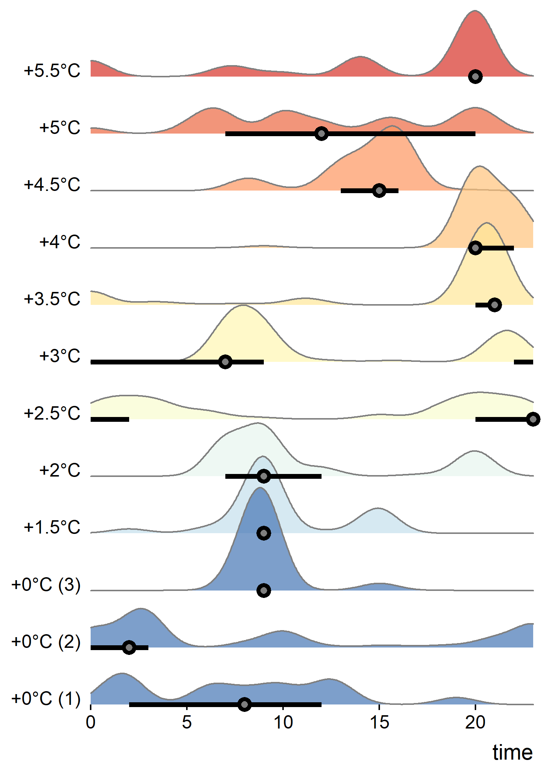

Here there is an actual trend in the distribution as well as the median time going from earlier to later in the day as temperature goes from ambient up to the highest warming treatment. The median time trend, when using the proper circular statistics, actually shows a positive coefficient not overlapping zero in its 95% credible interval, showing that this species was foraging significantly later in the hotter chambers. It looks like it forages more in the morning under ambient conditions but shits to late evening or night in warmed conditions.

## Prenolepis imparis, Duke Forest, winter

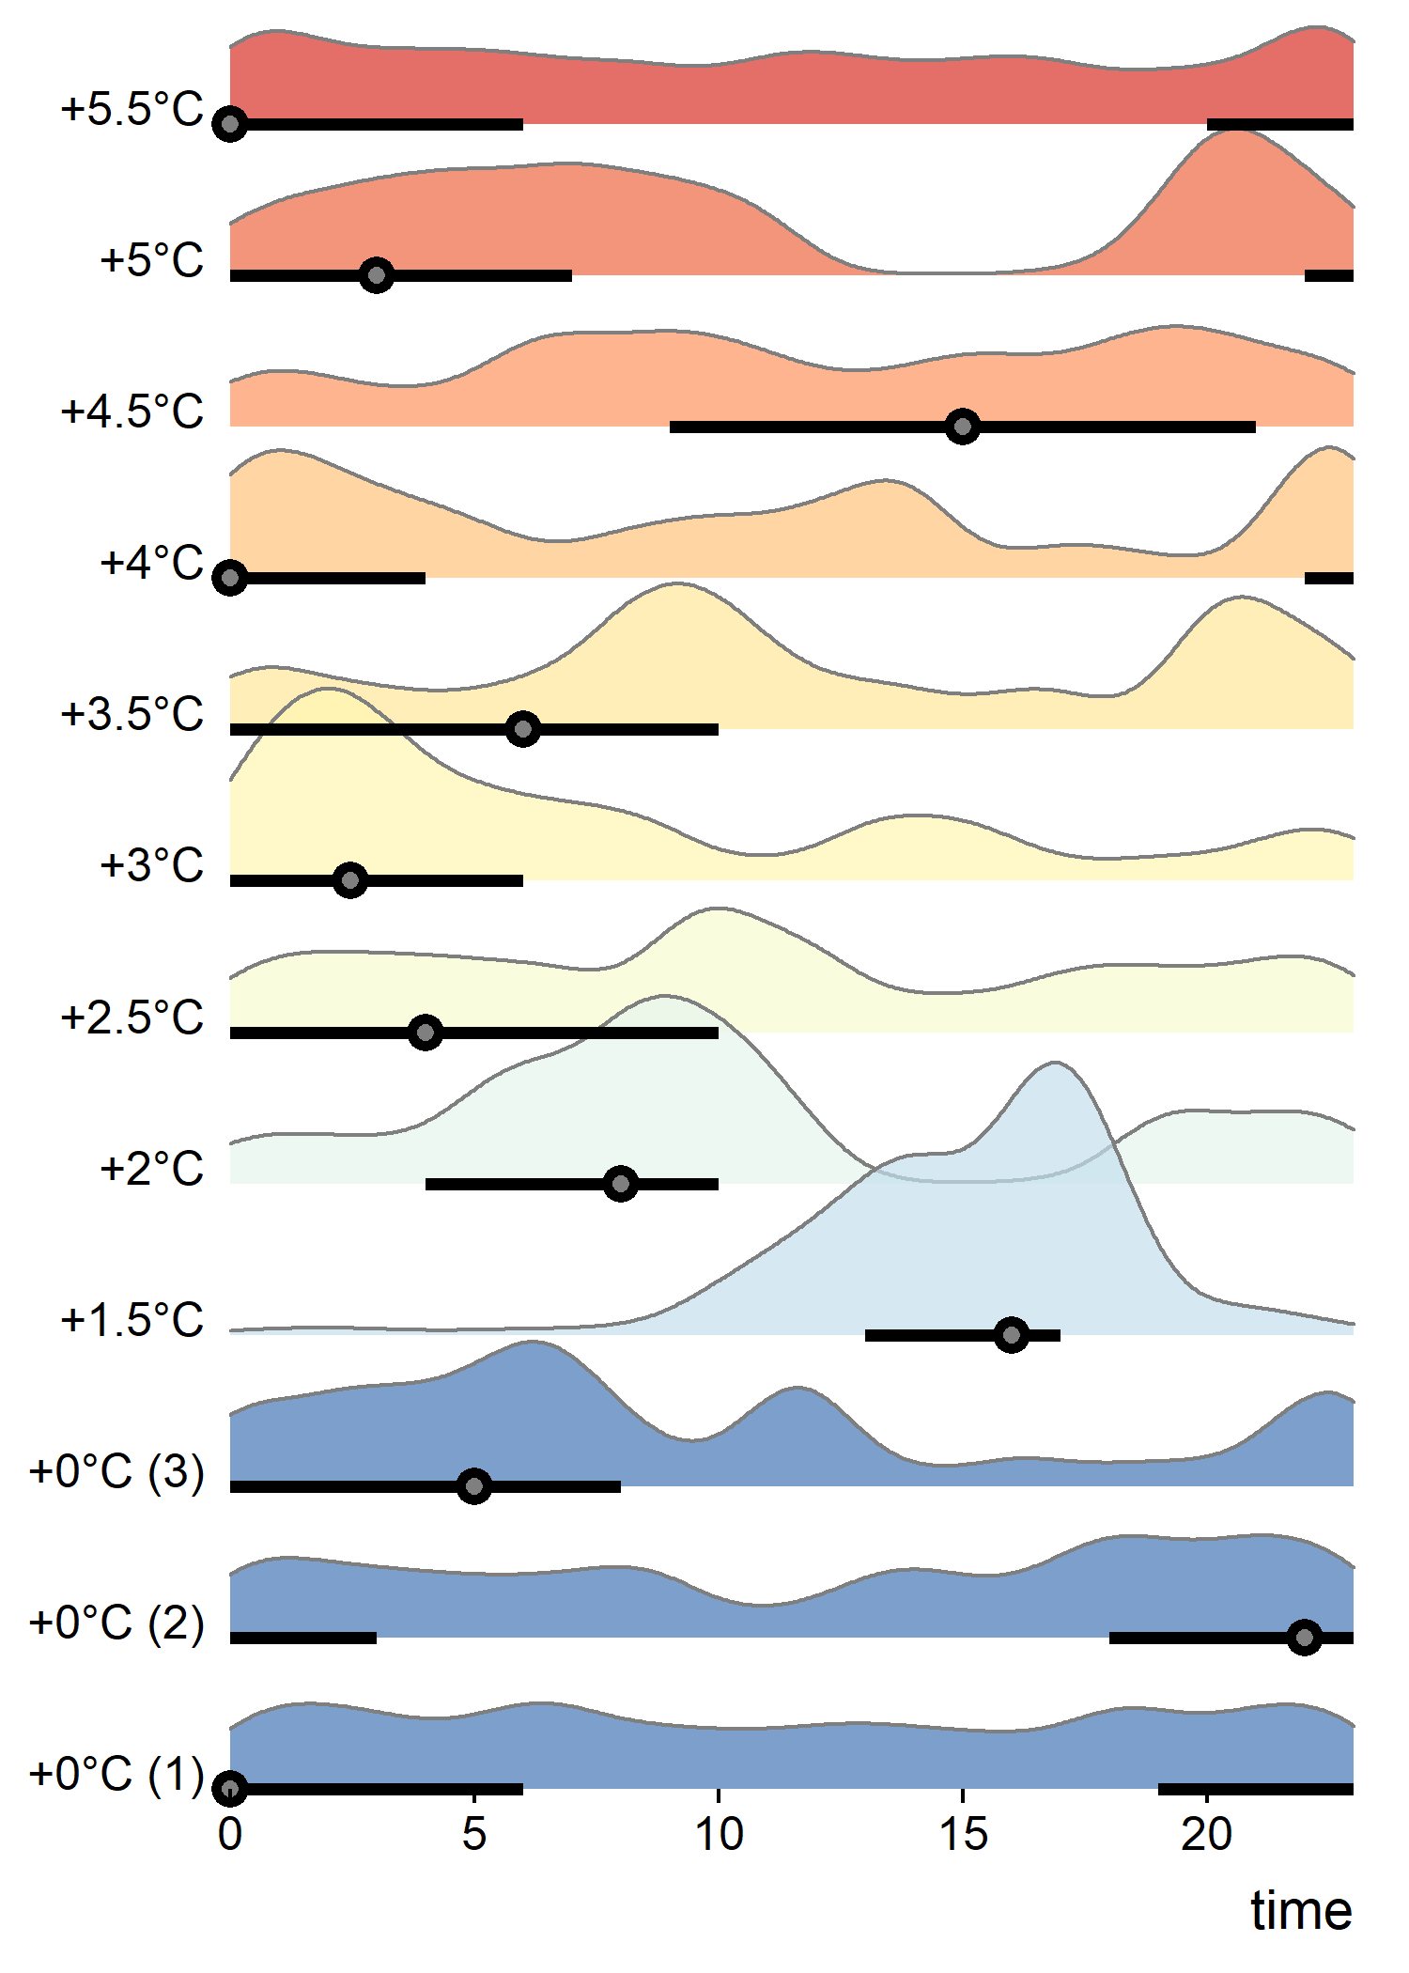

For Prenolepis in the winter at Duke Forest, there is no trend in foraging time with temperature. It looks like the ants are foraging at high abundance basically all throughout the day. The median time moves around some but not consistently with temperature.

## Prenolepis imparis, Duke Forest, summer

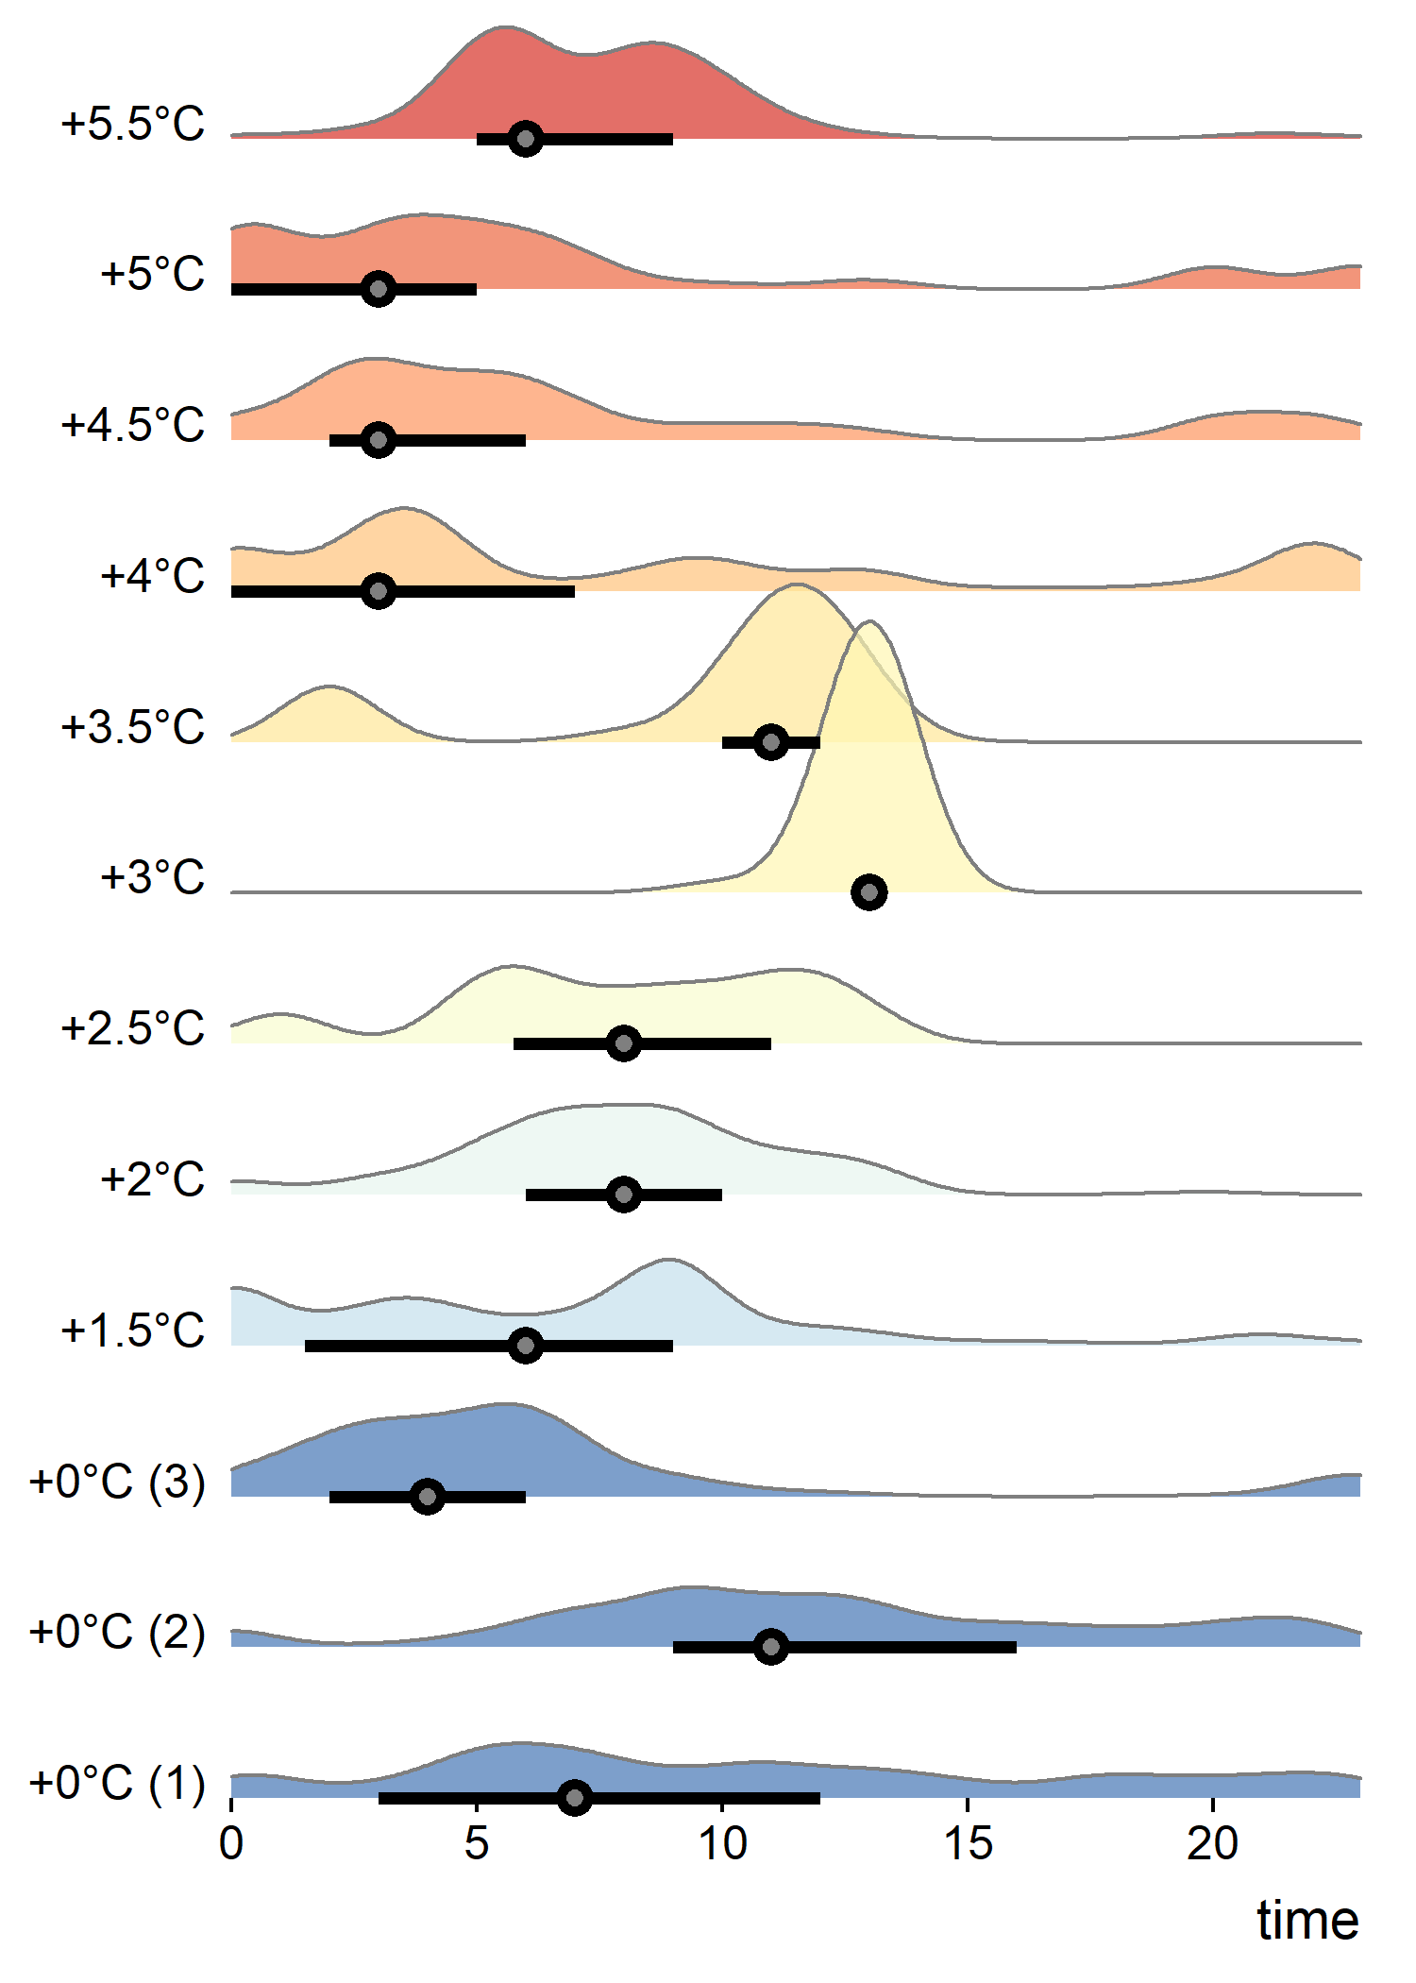

For Prenolepis in the summer at Duke Forest, the foraging time is more concentrated at certain times of day. There is a weak trend in the median time going from mid-morning to “wee hours” of the morning as temperature increases.

### Camponotus castaneus, Duke Forest, all months

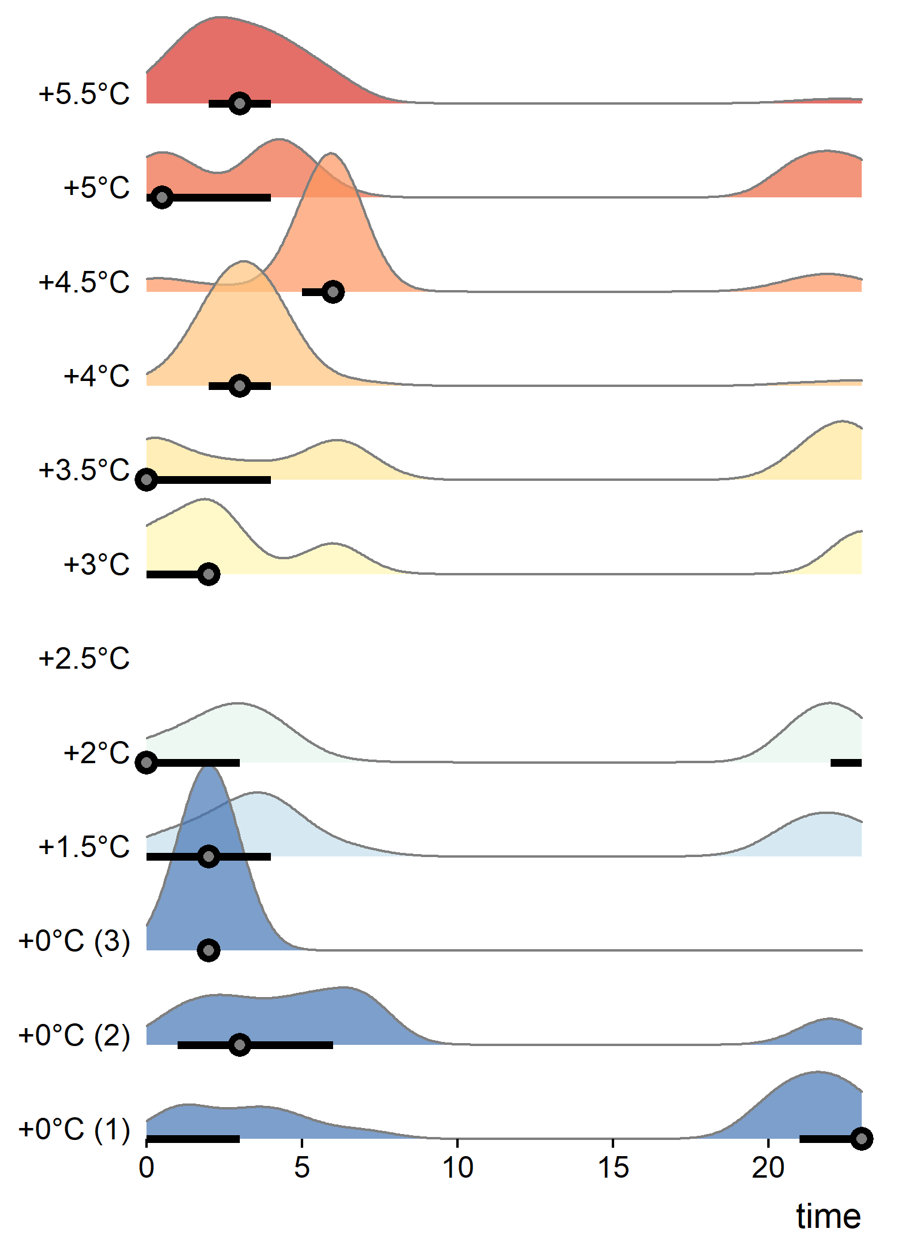

I thought this was a good example of a very consistent foraging time (median is almost always between midnight and 3 or 4 AM, regardless of treatment). This is a good sign that the lack of trend is not a cause of low sample size, instead it is actually good evidence that *Camponotus castaneus* is really not responding at all to the temperature treatment.